Press release from Surfstage Festival.
For immediate use.

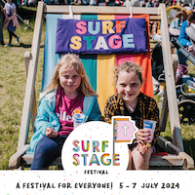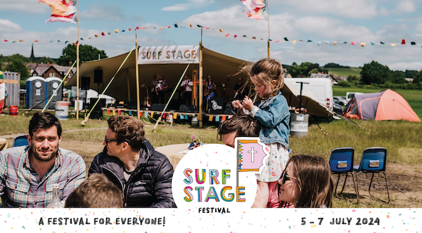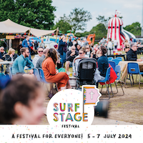

Surfstage – Not just another festival!

Two sisters from St John the Baptist Church in Burscough have created a festival where everyone experiences God's love. This is not just another festival; its a place where people who would never set foot in a church stumble into God's presence.
.

Not just for Christians, their event in Parbold has the feel of a family music festival where anyone, faith or no faith, can gently experience an atmosphere soaked in the Holy Spirit.

Rachel tells us “We believe God asked us to create a festival playing worship music, at the same time as being a format that welcomes people who don’t attend church or know God. We felt He wanted to unite lots of different people, organisations and churches throughout the North West in one place to experience God's love”.

Last year, they welcomed over 3000 people, Put on 15 bands, Provided free adult, youth and kids activities, Prayed over and into the lives of hundreds, pulled a lot of pints and sold a lot of burgers!

The festival showcases a huge range of live music from all kinds of bands, church and secular, a bar by their local microbrewery and street food. They have planned a jam packed family funday with bouncy castles, games, sports, activity trails, playground, adult craft workshops, a toddler tent, festival glitter, the Spirit Café and a prayer tombola where people pick out scriptures and blessings. Each morning and evening, they host celebrations with worship and inspirational speakers.

The Surfstage team have a heart for youth and making young people especially welcome is key to the festival; they have created a dedicated youth hangout tent and a youth after hours programme to reach ages 12 and up.

Rachel Birkett and Katie Street run a hospitality events business and have organised secular music festivals for a number of years. Inspired by their love for festivals like New Wine, they set about creating a local festival that anyone could afford to enjoy. Entry to the festival and all the activities are free and they achieve this with a huge team of volunteers.

Katie says “We want to create a festival everyone can enjoy. It’s not easy for most people to travel miles or buy expensive festival tickets so we make entry to Surfstage and all the activities for adults and kids free.”

Since 2019 the sisters have been nurturing something special and they have seen it grow. Surfstage (Surf – share UR faith) began 5 years ago where over 2000 visitors descended on their local playing fields and the response was fantastic. It has grown from a one day funday into an annual weekend event on their own 14 acre field in Parbold and now includes affordable camping as an alternative to big summer camps.

To date, the pair have funded the event themselves but this year they have setup as a CIO to apply for additional funding to help the festival grow. Any donations we do collect go to our charity Partners International Needs UK

Their vision for the festival is exciting! “We believe God wants to move significantly by his Spirit through SurfStage to bless the north west and reach the unchurched. We are looking for people and churches to join us in this mission”. Anyone wanting know more is encouraged to get in touch.

Surfstage this year takes place in Parbold, West Lancashire on
Friday 5th July – Sunday 7th July 2024.

For full details visit:
www.surfstage.co.uk facebook.com/thesurfstage instagram.com/thesurfstage

<ends>

Media Contacts
Katie Street E: hello@surfstage.co.uk M: 07976 934652
Rachel Birkett M: 07811 136282

